- Navigate to PIG_HOME/bin
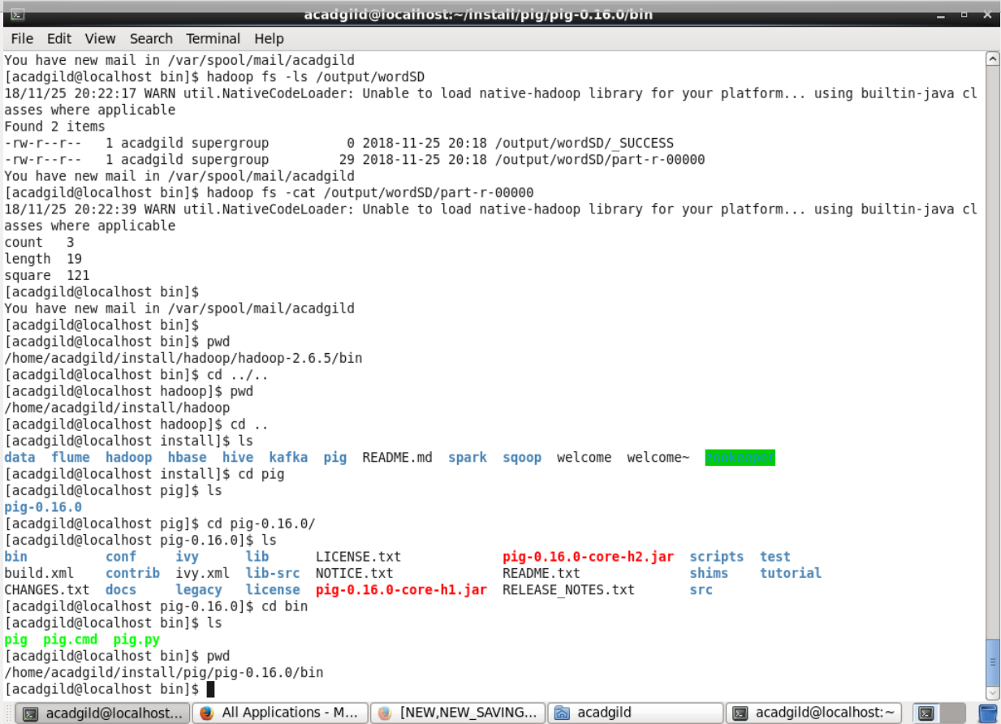

- Created a new text file to process
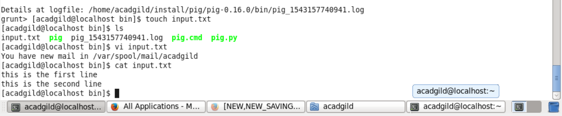

- Started pig service
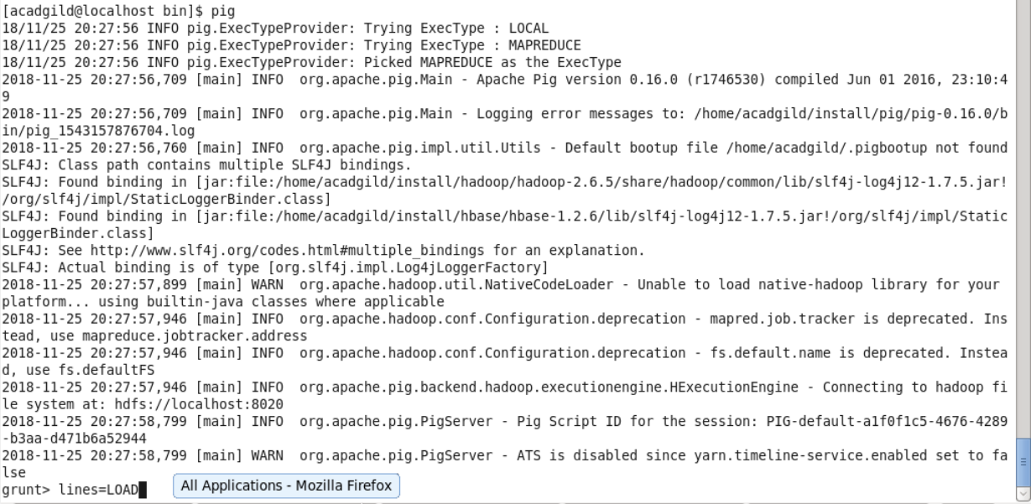

- Moved the text file to HDFS using PUT

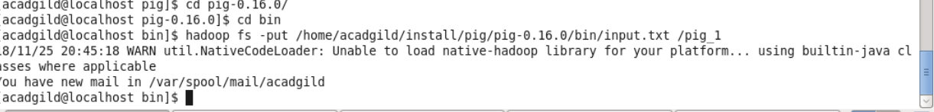

- Started PIG daemon and executed the code
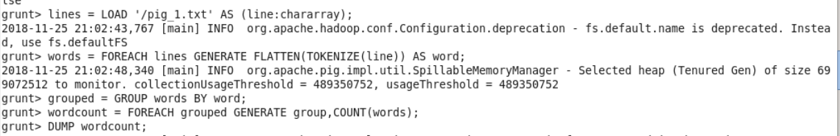

- Confirmed the output:

